Hans-Heinrich Reckeweg Clinical Case Award 2016
Submission Form
Click here to enter your name and those of your co-authors. If there is more than one author please indicate which author is the corresponding author.
Please submit the completed Submission Form electronically to reckeweg.award@heel.com

AND the hard copy along with the original signed consent forms to:

Dr. Konstantin Cesnulevicius
Department of Medicine
Biologische Heilmittel Heel GmbH
Dr.-Reckeweg-Str. 2-4
76532 Baden-Baden
Germany
Table of Contents

Case Report Considerations 2
Author Information 3
Submission Instructions 3
Disclaimer 3
1. Title 4
2. Key Words 4
3. Introduction 4
4. Patient Information and Presenting Concerns 4
5. Clinical Findings 4
6. Timeline 4
7. Diagnostic focus and assessment 6
8. Bioregulatory systems medicine assessment 6
9. Therapeutic focus and assessment 6
10. Bioregulatory systems medicine therapy protocol 7
11. Follow-up and outcomes 7
12. Discussion 7
13. Informed Consent 7
14. Patient perspective (optional) 7

Case Report Considerations

Please consider these if your planned submission meets the following criteria for a case report.

- The case report contributes to the current medical literature.

- I am reporting beneficial response to treatment, a novel treatment, an unexpected outcome, an unexpected event during treatment, and/or an adverse response to treatment.

- I have pre- and post- objective findings surrounding treatment(s). Objective data includes lab values, imaging, physical exams, and validated patient reported instruments such as quality of life measurements.

- I have obtained informed consent from the patient to report and publish his/her case on file.

- I excluded identifying data or protected health information of this patient.

- If necessary, I have required approval from an Ethics Commission or Institutional Review Board (IRB). Most case reports will not require this approval.

- All authors must disclose any competing interests or conflict(s) of interest. In general, this should not adversely affect your submission.

If your case fulfills the above criteria, please continue…

Author Information
Please fill ALL fields. This information will remain confidential and be used only for purposes of this award
Last name: Click here to enter text.
First name: Click here to enter text.
Specialty: Click here to enter text.
Affiliation: Click here to enter text.
Address: Click here to enter text.
Postal code: Click here to enter text.
Country: Click here to enter text.
☐ I herewith declare that I have read the “Reckeweg Award Conditions of Entry” and accept such conditions. (Please check the box if you confirm. Submission Forms with unchecked box will be NOT accepted).

Submission Instructions
Please read these instructions carefully before filling the submission form.
The submission form is organized into separate sections that need to be filled with the requested information. Each section has an expanding text field box that can be expanded to accommodate your text. The information amount for each section may exceed one page. Graphic files such as clinical images and numerical data (such as tables and laboratory data) should be inserted into the relevant sections of this form.
COMPLETED Submission Forms are REQUIRED for this Competition

After submission, you will receive a notification letter informing whether your submission was accepted for further revision. Each completed submission form will be revised by an international Award Review Committee, which will evaluate each section separately.

Disclaimer
This form was developed in concordance with the latest CARE guidelines. The CARE guidelines provide a framework that supports transparency and accuracy in the publication of case reports and the reporting of information from patient encounters.

1. Title
Include the words “case report” in the title. Describe what is of greatest interest to you as the author. This could be the presentation, the diagnosis, a test result, the intervention, or the outcome.
Enter text here

2. Key Words
Provide 2 to 5 key words that identify areas covered in this case report that will help readers locate this case report.
Enter text here

3. Introduction
Briefly summarize the background and context of this case report. Include how it contributes to the bioregulatory medical literature.
Enter text here

4. Patient Information and Presenting Concerns
Describe the patient characteristics (such as the relevant demographics—age, gender, ethnicity, occupations) and their presenting concerns with relevant details of related past interventions. Please include important medical, family, and psychosocial history including lifestyle and genetic information related to the main topic of this case report. Include other pertinent co-morbidities and interventions including self-care.
Enter text here

5. Clinical Findings
Describe important physical examination (PE) and clinical findings, include diagnostic test results.
Enter text here

6. Timeline
Create a timeline that reports important milestones related to patient diagnoses and interventions and includes specific dates and times in a table, figure, or graphic. See two examples below that are available on the CARE website:
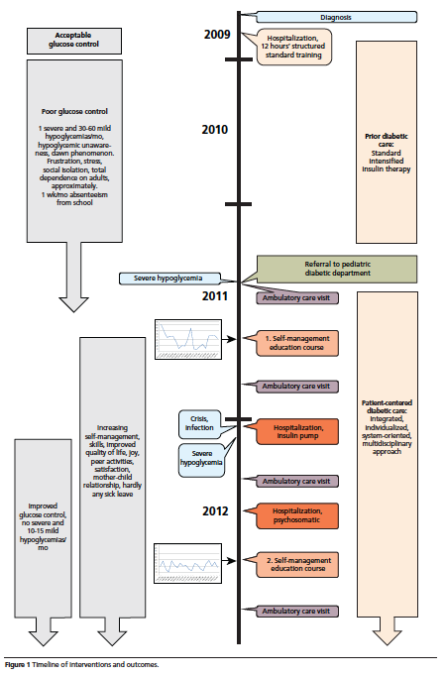

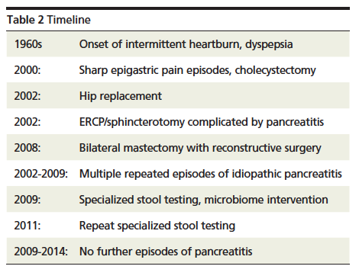

7. Diagnostic focus and assessment
Provide an assessment of the (1) diagnostic methods (including laboratory testing, imaging results, questionnaires, referral diagnostic information); (2) diagnostic challenges (such as limited ability to complete an evaluation, patient availability, financial, cultural); (3) diagnostic reasoning including other diagnoses considered, and (4) prognostic characteristics (such as staging in oncology) where applicable.
Enter text here

8. Bioregulatory systems medicine assessment
Provide an assessment of the (1) diagnostic reasoning that describes patients ability to self-regulate; (2) identified pathophysiological sequence of events in this patient; (3) identified inflammation pattern in this patient; (4) network of organs or tissues that underlies the patient condition.
Enter text here

9. Therapeutic focus and assessment
Describe the (1) types of interventions (such as pharmacologic, surgical, preventive, lifestyle, self-care) and (2) administration and intensity of the intervention (including dosage, strength, duration, frequency).
Enter text here

10. Bioregulatory systems medicine therapy protocol
Describe the (1) rationale for the bioregulatory therapy protocol utilized, (2) types of bioregulatory interventions, (3) administration and intensity of the intervention (including dosage, strength, duration, and frequency).
Enter text here

11. Follow-up and outcomes
Please describe the clinical course of this case including all follow-up visits as well as (1) intervention modification, interruption, or discontinuation, and the reasons; (2) adherence to the intervention and how this was assessed; and (3) adverse effects or unanticipated events. Please describe (1) patient-reported outcomes, (2) clinician assessed and reported outcomes, and (3) important positive and negative test results.
Enter text here

12. Discussion
Please describe the strengths and limitations of this case report including case management, and the scientific and medical literature related to this case report, particularly in the areas of bioregulatory medicine. Discuss the rationale for your conclusions such as potential causation and the ways this case might be generalized to a larger population of practitioners who may or may not be familiar with bioregulatory medicine. Finally, what are the main findings of this case report and what are the 'take-away' messages?
Enter text here

13. Informed Consent
Attach the informed consent form signed by the patient for the publication of this case report.

14. Patient perspective (optional)
Whenever appropriate, the patient should share their experience of their care in a narrative published within this case report.
Enter text here
COMPLETED Submission Forms are REQUIRED for this Competition

Gagnier J, Kienle G, Altman DG, Moher D, Sox H, Riley DS, and the CARE group. The CARE guidelines: consensus-based clinical case report guideline development. Journal of Clinical Epidemiology; 67(1),46-51.

